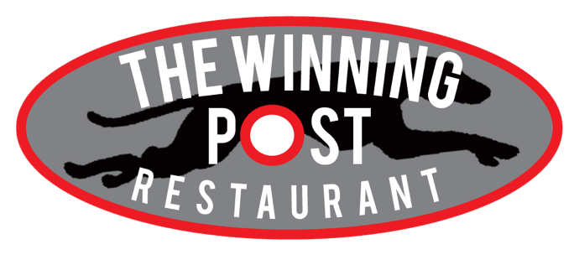

www.henlowdogs.co.uk
CHRISTMAS PARTY MENU 2019
The Greyhound Stadium, Bedford Road (A600), Lower Stondon, Bedfordshire, SG16 6EA
Tel: 01462 851850 Fax: 01462 815593 Email: info@henlowdogs.co.uk
IMPORTANT: Please note that we are unable to change course on the night, so it is important if someone wishes to change their mind about a starter or main that we receive this information prior to you coming.
Booking Name: ……………………………………………………………………………………………………………………………………
Total Number in Party: …………………………………….…… Date of Booking: …………………………………………
NAME | STARTER | MAIN COURSE | DESSERT
TOTAL TALLY OF FOOD CHOICES FOR EACH PERSON FROM THE GUEST LIST ABOVE
STARTERS | TALLY
Homemade Roasted Red Pepper & Sweet Potato Soup
Served with a bread roll and butter
Breaded Camembert
Served with Cranberry sauce and a side of mixed leaves
Smoked Salmon
Served with Crème Fraiche and Beetroot
Prawn Cocktail
Served with a Marie Rose sauce accompanied with roll and butter
Chicken Liver Pate
Served with Melba Toast and caramelised onion chutney
Duck Spring Rolls
Served with a Hoi Sin sauce
MAIN (All the main dishes are served with a selection of seasonal vegetables) | TALLY
Traditional Turkey Crown
With stuffing, roast potatoes, chipolata wrapped in bacon and a Yorkshire Pudding
Seared Duck Breast
Served with a Port sauce and Dauphinoise potatoes
Lamb Shank
Served with mashed potato and a Garlic mint sauce
Salmon Steak
Served in a dill & white wine Sauce
Halloumi Veg Stack (V)
Accompanied with a Pesto dressing
Goats Cheese & Red Onion Tart (V)
Finished with a Balsamic glaze
DESSERTS | TALLY
Traditional Christmas Pudding
Served with Brandy sauce
Salted Caramel Profiteroles
Served with vanilla ice cream
Christmas Yule Log
Served with vanilla ice cream
Strawberry Fuse Cheesecake
Served with vanilla ice cream
Crème Brûlée
Served with vanilla ice cream
Fresh Fruit Salad (V)
Served with fresh cream
SPECIAL REQUIREMENTS / REQUESTS

